6.25

Market not directional, with lots of broken movements.

MA trading requires more clear index movements. This needs time constraint like pm 2-3 or something. (morning not really clear)

AM_HEDGE: wasn’t on because delta < 0

PercchY > 0 last day, unless both f10 indicators are true (in which case trade percentile trader), else trade amhedge.

If percCHY <0, then can do slowCover, if 2 indicators are true, can do bulk unhedging.

IndexMA : put on intraday perc restrictions, otherwise too many weird (low sharpe) trades, cannot add position in this scenario (cannot scale up delta)

After market:

Today’s market was suitable for Am hedge.

PMCHY > 0 , first 10 maxT < first10 min, only open>prevC.

Index is very long term weaker than other indices, ideal for hedging other exposures.

Test trade result:

09:26 future trade::price size 12082.5 1 result -257.5

09:35 future trade::price size 12097.5 -1 result 272.5

09:42 future trade::price size 12120.0 1 result -295.0

09:48 future trade::price size 12097.5 -1 result 272.5

10:17 future trade::price size 12050.0 1 result -225.0

10:22 future trade::price size 12060.0 -1 result 235.0

10:26 future trade::price size 12062.5 1 result -237.5

10:33 future trade::price size 12057.5 -1 result 232.5

10:51 future trade::price size 12027.5 1 result -202.5

11:07 future trade::price size 12042.5 -1 result 217.5

11:24 future trade::price size 12055.0 1 result -230.0

13:07 future trade::price size 12045.0 -1 result 220.0

13:32 future trade::price size 11997.5 1 result -172.5

13:35 future trade::price size 11995.0 -1 result 170.0

13:54 future trade::price size 11952.5 1 result -127.5

13:59 future trade::price size 11940.0 -1 result 115.0

14:09 future trade::price size 11950.0 1 result -125.0

14:26 future trade::price size 11955.0 -1 result 130.0

overall pnl -7.5

am -217.5

pm 210.0

by am {false=210.0, true=-217.5}

avg pnl by hour {9=-7.5, 10=-197.5, 11=-12.5, 13=205.0, 14=5.0}

number of trades by hour {9=4, 10=5, 11=2, 13=5, 14=2}

avg distance between trades by hour {9=12.75, 10=10.0, 11=60.0, 13=12.4, 14=25.5}

Should trade close of day (2pm onwards).

Slaughter the retail with their hands tied behind their back.

**6.26**

Trades analysis:

*** 2018-06-26 ***

1345 index MA buy T: 09:33:04.603 Order: BUY LMT 1.0 at 11782.5 msg: Tradetype INDEX_MA 1345 Status: Unknown FinalT: 00:00 Last shortlong 11786.71 11782.43 SecLast Shortlong 11778.39 11782.55

||Order|| 1345 101 T: 09:33:04.603 Order: BUY LMT 1.0 at 11782.5 msg: Tradetype INDEX_MA 1345 Status: Filled FinalT: 09:33:04.946 Filled

* This is a trade at the open where nothing is sure. Trade with less size.

1346

day cover T: 09:34:14.384 Order: BUY LMT 3.0 at 11752.5 msg: Tradetype SLOW_COVER 1346 Status: Unknown FinalT: 00:00 todayP% 4

||Order|| 1346 102 T: 09:34:14.384 Order: BUY LMT 3.0 at 11752.5 msg: Tradetype SLOW_COVER 1346 Status: Filled FinalT: 09:34:15.102 Filled

* Size too big

1347

day cover T: 09:49:17.217 Order: BUY LMT 3.0 at 11752.5 msg: Tradetype SLOW_COVER 1347 Status: Unknown FinalT: 00:00 todayP% 4

||Order|| 1347 103 T: 09:49:17.217 Order: BUY LMT 3.0 at 11752.5 msg: Tradetype SLOW_COVER 1347 Status: Filled FinalT: 09:49:18.144 Filled

* Size is too big, there is no change in direction -> change size to 1

1348

day cover T: 10:04:18.165 Order: BUY LMT 2.0 at 11650.0 msg: Tradetype SLOW_COVER 1348 Status: Unknown FinalT: 00:00 todayP% 2

||Order|| 1348 104 T: 10:04:18.165 Order: BUY LMT 2.0 at 11650.0 msg: Tradetype SLOW_COVER 1348 Status: Filled FinalT: 10:04:21.291 Filled

* This slow cover size is big, there wasn’t any change of direction. Should not long here.

1349

index MA buy T: 10:18:02.007 Order: BUY LMT 1.0 at 11612.5 msg: Tradetype INDEX_MA 1349 Status: Unknown FinalT: 00:00 Last shortlong 11605.59 11600.48 SecLast Shortlong 11602.02 11603.45

||Order|| 1349 105 T: 10:18:02.007 Order: BUY LMT 1.0 at 11612.5 msg: Tradetype INDEX_MA 1349 Status: Filled FinalT: 10:18:03.168 Filled

* Very good trade.

1352

last hr MA buy T: 14:27:01.032 Order: BUY LMT 1.0 at 11692.5 msg: Tradetype LAST_HOUR_MA 1352 Status: Unknown FinalT: 00:00 Last shortlong 11703.04 11701.79 SecLast Shortlong 11699.71 11702.39

||Order|| 1352 101 T: 14:27:01.032 Order: BUY LMT 1.0 at 11692.5 msg: Tradetype LAST_HOUR_MA 1352 Status: Filled FinalT: 14:27:01.227 Filled

* This trade was flat

1353

last hr MA buy T: 14:43:05.394 Order: BUY LMT 1.0 at 11650.0 msg: Tradetype LAST_HOUR_MA 1353 Status: Unknown FinalT: 00:00 Last shortlong 11677.01 11676.95 SecLast Shortlong 11678.08 11678.14

||Order|| 1353 102 T: 14:43:05.394 Order: BUY LMT 1.0 at 11650.0 msg: Tradetype LAST_HOUR_MA 1353 Status: Filled FinalT: 14:43:05.579 Filled

* Good trade

1356

trim sell T: 15:16:09.184 Order: SELL LMT 1.0 at 11685.0 msg: Tradetype TRIM 1356 Status: Unknown FinalT: 00:00

||Order|| 1356 101 T: 15:16:09.184 Order: SELL LMT 1.0 at 11685.0 msg: Tradetype TRIM 1356 Status: Filled FinalT: 15:16:11.490 Filled

Neutral trade – getting rid of delta

Overall:

Index ma and last hour MA was making money.

Slow cover trader was buying with big sizes and too fast and was losing.

Increase size on index MA and last hour MA.

Index MA is the best because it trades at good percentile with a change in direction, whereas slow cover trader just buys mindlessly.

Changes:

* Bigger sizes on index MA and last hour MA
* Smaller sizes on slow cover trader
* Trim delta starts right at 15:00 and cuts all the way until delta < upper bullish limit
* Add pmpercY change to index ma, only trade when advantageous.
* Open trades need to have less size, these are volatile and changes happen a lot, markets are unstable.

Reflections:

* Today’s trade pnl lost money, due to slow cover trader buying big sizes mindlessly every 15 minutes, without any other parameters
* There was no sells which was good, as today is expected to go up.
* All the buys were at their relatively low percentile.
* Last hour trader worked, it is its first day operational, it ignored the percentile and only takes into account pmchy at the cross

6/26

Why do A share instead of other indicies?

1. Markets are more volatile
2. Index is manipulated at the close.
3. Index is controlled by long only investors selling panic and buying greed, so volatility will be high.

Other indices/stocks:

1. US and hk

6.27

Markets are too volatile.

Suspend blind covering, aggressive covering +

Focus on 2 line MA trading.

1. One is percentile based, this one can use big position (percentile_MA). This one uses smaller MA periods.
2. One is not percentile based (last hour trader), this one is (unconditional_MA). This uses bigger MA periods and capture bigger trends.
3. When markets are more volatile, use bigger MA periods

**14:39**

1. Bought a lot through fastCover, turn out to be deadly. There was too many buying trades, bought too much delta, and market just crashed. These covering trades are likely aimless shots. Index was dropping so only buying was allowed, resulting in too much delta.
2. Suspend all the covering trades immediately (fastCover and slowCover)
3. Covering will be done through percentile_MA going forward, no cover unless MA touch
4. UnconditionalMA will determine delta and general trend. There is not supposed to be more than 3 per day changes in unconditional MA. Adaptively, unconditional MA needs to be as wide as possible but no wider.
5. Size on the unconditional MA needs to be significant. These are general delta swings, but test them for a few days.
6. Reduce size on all trades for this week.
7. Reduce hard limits to -250k to 500000. 2.5mm expansion was rash.
8. Ptf swing is too much. Intraday vol is too high.
9. Trim all the delta tonight.

6.28

Ytd added too many through fast_cover trader – don’t do that, there was no crosses

Need to buy back through

1. percentileMATrader (trades at crosses at low percentile)
2. unconditionalMATrader (trades at crosses regardless of percentile)
3. trendFollowingTrader

Trend following trader (scrap this idea, go back to simple day moving average)

1. the longer a trend has been in, the longer it is expected to last
2. no buying in a negative trend (ytd’s problem)
3. open:
4. close: on MA crosses or

Scrap this idea. Focus on big picture

1. Future delta follows day 20D/60D direction
2. Currently market is bear, keep hedge on, don’t swing to positive. (ytd swung to a delta of 2.5mm, then cut to 200k, traded 5mm of delta )
3. When markets are bull, keep positive don’t swing to negative
4. Mistakes were made in Feb, were having big positive position
5. Trade day candle, trade delta. Focus on day trend, not mini mini trend, these are intractable.
6. Trend trading, delta trading.
7. Intraday trading is not making money, in fact, it is losing money.
8. There are a lot of transaction costs involved.
9. The 60k loss yesterday was due to 追反弹, and cutting position afterwards. This resulted in a lot of transaction cost and is not smart.
10. Avoid trading intraday that has to be cut intraday with huge size. This will cause inflexible trading.
11. Focus on trend pnl, not trading pnl. Trend pnl on the future side made money in Jun, just increase it, don’t overtrade.
12. Fast, inventory, PD, flatten traders didn’t work. Cover trade covered too much and don’t work. Percentile MA worked.
13. Don’t want too much swing. During bear market fut size goes from flat <–> negative.
14. Cut position on all the trading strategies.
15. Stop futures overtrading.

Reflections:

1. Don’t alter stock positions.
2. Focus on trend delta, not trading delta.
3. Follow MA closely. Follow vol closely. Vol up, short.
4. Daily trading in small range – never too big, trading pnl is losing money every week.
5. Last year was bull market everywhere. Put on trend delta and leave it there. Don’t day trade. Day moves are not tractable to be analyzed.
6. Lessons from 2015 stock market turmoil. Manually trading intraday resulted in loss. General delta direction needs to be in the direction of MA.
7. In bear markets, when CL is big, next day will face selling pressure from previous day’s short term traders (who bought)
8. In bull bears, when CH is big, next day will face buying pressure from the buyers (who sold).

Overall:

1. This year’s losses was from Feb. Massive long position, 7mm delta, markets were volatile. This cost about 500k.
2. Intraday pnl don’t matter.
3. Delta level is important. Most profits comes from trend pnl, not trading pnl.
4. Last yr’s bull market: buying and selling didn’t make money. Holding blue chips made money.

Additional:

1. When index breaking new lows, don’t be naively expect rebound. Keep short position
2. When there is clear reason for drop like rmb depreciation, keep short position
3. Neg autocorrelation is due to short term traders, day traders pay that to play day by day. Don’t pay that fee, charge that fee or don’t play at all. Ytd, paid the fee through buying too much, selling back at discount (round trip very expensive).
4. Everyday has been a new low, very easy to break new lows – switching delta direction is definitely wrong.
5. 6/20 started to break new lows – not the place to be long.

14:24

1. Halt unconditional MA trading – logic doenst make sense, losing too much money
2. During the day, trade limitedly percentileMA, put everything else to stop
3. Start trading day-K MA, (5, 20, 60 day MA to determine delta)
4. Need to short more here below MA.
5. Keep short overnight
6. Model: long strong, good stocks worldwide vs. short china futures. (China futures is mostly banks and insurance, this sector will underperform world equity)
7. Start adding quality stocks on the US side.
8. Stabilize delta here first, short more at highs. Target is short -500 to -1m

6.29

1. control volatility of ptf (had a 60k loss due to fut pos flipping to the positive side – avoid this)
2. Fut delta is in the direction of Ma20, no flipping direction intraday. Control delta to small size.
3. Trades are submitted based on percentileMA.
4. Take overnight risk as well

14:54

1. Set up percentile ma, can trade whenever markets are open
2. Low percentile, ma cross and ytd pm drop
3. Take overnight risk
4. 0 manual trades
5. no more fast/slow cover without ma crosses solely based on percentile
6. simplify whole process as much as possible. Currently too complicated.
7. Trading cannot be based on time, because it results in overtrading, but minimum time spacing needs to be established between 2 orders.

Week review:

Stock: stock down -54k. Friday was a weak rebound following 4 bloody days.

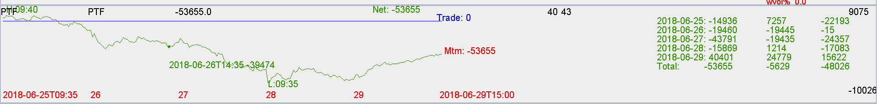

Fut: hedging was not good due to bad trading on Wednesday.

Keep hedging on and don’t overtrade the hedge.

Expired Jun future: Be extra careful around expiry. Short rollers are the majority and futs are trading at deep discounts due to short rollers, very hard for market to rebound.

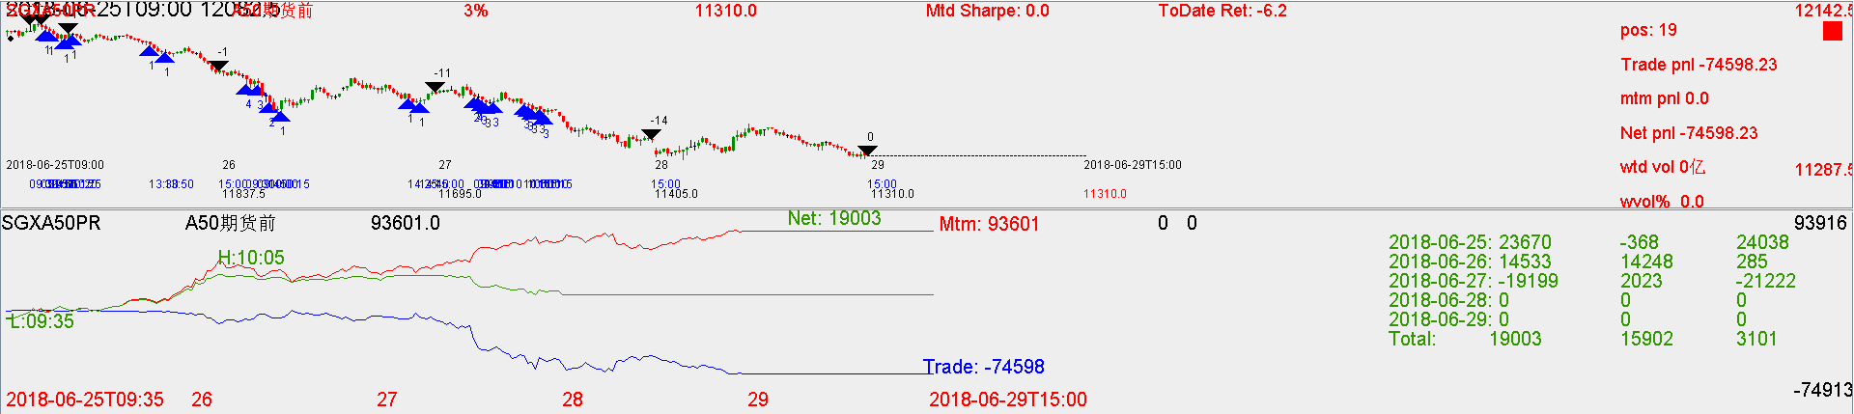

Jul Future: rolled at discount, paying a lot for that.

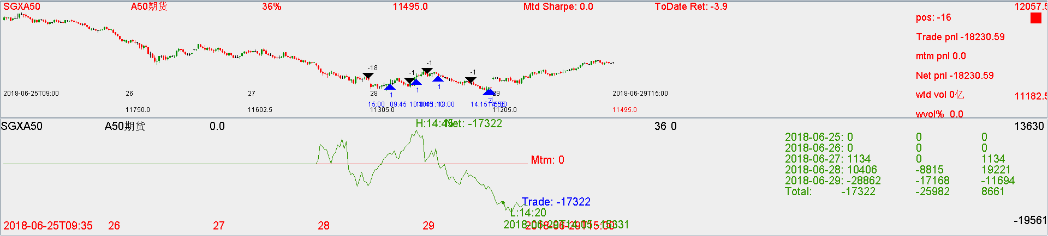

Correct maneuver before expiry and what to avoid

1. Narrow down delta limits before expiry (overtrading on wed was deadly, added 30 lots and cut 30 and shorted another 15)
2. Trade lightly before expiry
3. Keep a short bias before expiry.
4. Avoid rolling at deep discounts.
5. Percentile MA needs to work overnight.

This week with futures:

paid for the roll (expensive)

paid for the delta flip on Wednesday (traded 5mm rmb of delta, bought 30 and sold 30). Index closed at the lowest.

Due to the need to short roll, the back month future traded at very bad discounts. (-1.8%)

You rolled them fully. This was not good.

When you trade big sizes, you are left in a bad position if the trade doesn't work out, you need to cut and hedge at the worst level, you need to **trade less size**, and take market risk at unwanted levels. This is the way to profit.

Limit delta to 25% of total ptf. You should feel comfortable if stock ptf is unhedged.

Trading randomly will cause loss because trading will be at the worst levels.